

***SF-2.0T/3.0T/1150 VFFS Vertical Form Fill Seal & Packing Machine***

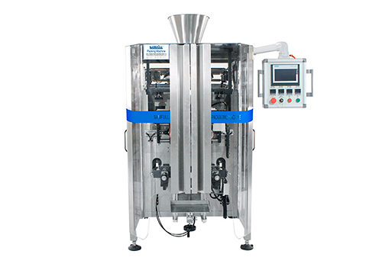

This versatile vffs vertical form fill seal machine is suitable for solid bulk products, powder and liquid, with fully automatically weighing, filling, bag making, date printing and gas flushing functions.

**Kindly reminder**

Please tell us the following information while you send us an inquiry. Base on your message, we will suggest the optimum solution to you for reference. Thank you.

1. Your product

2. Bag dimension

3. Bag weight

4. Bag shape

5. Output capacity

**Technical Parameters**

|  |  |  |  |
| --- | --- | --- | --- |
| **Model** | **SF-2.0T** | **SF-3.0T** | **SF-1150** |
| Bag sizes | L 80-400mm W 80-250mm | L 100-480mm W 150-350mm | L 200-800mm W 200-550mm |
| Packing speed | 5-70bags/min | 5-45bags/min | 5-10bags/min |
| Measuring range | 100-3000ml (up to 3kg) | 300-5000ml (up to 5kg) | 5000-15000ml (up to 15kg) |
| Packing material | OPP/CPP, OPP/PE, PET/PE, PE | | |
| Air Consumption | 6-8kgf/cm2, 0.45-0.6 m3 /min | | |
| Power and voltage | 110/220/380V, 50-60HZ, 4.75KW | 110/220/380V, 50-60HZ, 5KW | 110/220/380V, 50-60HZ, 3.5KW |