
SP-202 Vertical Form-Fill-Seal Machine for Powder / Granule

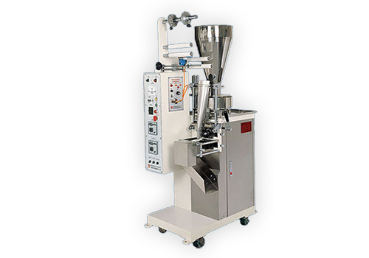

Vertical Form-Fill-Seal Machine SP-202 / SP-203 / SP-204 for packaging powder or granulated products such as coffee, medicine, flowers, tea leaves, fungus, peanuts, sugar, salt, etc.

Features:

- The machine is ideal for packaging powder and granulated products.

- Employs German photocell sensor for accurate control of bag length.

- Employs Japanese thermostat for fast heating and superior performance.

- The machine structure conforms to sanitation standards.

- Convenient, fast adjustment to suit various bag lengths.

- Fully automatic operation provides high efficiency and high productivity.

- Variable packaging speed, ranging from 40 - 80 bags per minute.

Specifications:

Model | SP-202
Bag Shaper | Pillow-Seal
Film Width | 60 - 160 mm
Bag Width | 30 - 80 mm
Bag Length | 50 - 120 mm
Packaging Speed | 40 - 80 bags/min
Volume Range | 30 g
Hopper Capacity | 20 L
Power Source | AC 110V 220V, 50/60Hz, 1 Phase
Power Consumption | 1.35 KW
Machine Dimensions | 900x600x1750mm
Case Dimensions | 1000x700x1900mm
Machine Weight | 300 kgs
Shipping Weight | 420 kgs

