
High Shear Mixer Granulator Model 25/50/100/150/250/400

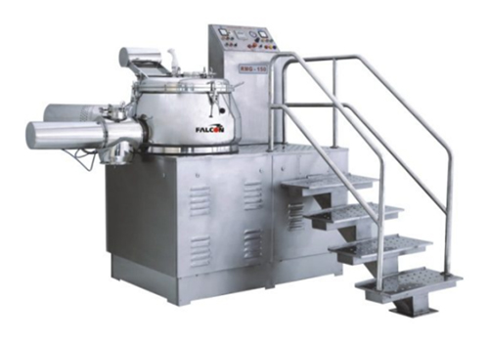

High Shear Mixer Granulator has been developed for mixing of ingredients used for wet granulation process. Multi blade impeller and chopper design is for better floating and tumbling of material for dry & wet mixing; it forms a uniform wet granules. The equipment will be design for suitable of Vacuum Transfer System for material loading.

Salient Features:

- Contact parts SS 316 8 Non contact parts SS 304
- Special design air purging facility
- Three OR Four blade impeller (customized) design
- Pneumatically operated discharge
- Four blade chopper design
- Heavy duty structure with platform & staircase
- Manual operated push button control
- PLC based operating panel can be provide as an option
- Interchangeability design for lab model up to 15 Liter

Technical Specification:

Model | 25 | 50 | 100 | 150 | 250 | 400
Gross Volume (Lim) | 25 | 50 | 100 | 150 | 250 | 400
Working Volume (Les) | 20.0 | 40 | 80 | 120 | 200 | 320
Impeller Motor kW/HP | 2.013.0 | 5.0/7.5 | 5/7.5 | 10/15 | 20/30 | 30/40
Impeller Blade RPM | 75/150 | 75/150 | 75/150 | 75/150 | 75/150 | 75/150
Chopper Motor kW/HP | 0.75/1.0 | 1.0/2.0 | 3.0/3.0 | 3.0/3.0 | 5.0/5.0 | 5.0/7.5
Chopper Motor RPM | 1500/3000 | 1500/3000 | 1500/3000 | 1500/3000 | 1500/3000 | 1500/3000

