
Semi Automatic Tin Metal Aluminum Plastic Ring Pull Food Can Sealing Machine

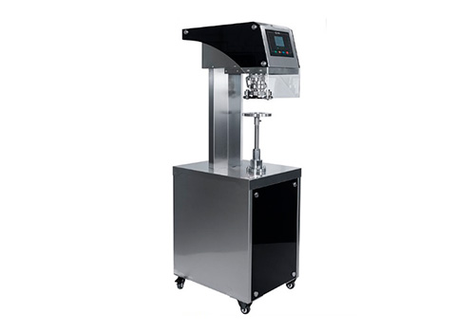

This machine is mainly used for sealing and packaging of various round PET plastic, iron, aluminum and paper cans, etc. With advanced product design, reasonable structure and easy and light operation, it is the ideal packaging equipment for food, medicine, tea and chemical industries.

Feature

1. Adopting the latest generation of mechanical design, the cans do not rotate during the sealing process. The sealing rollers rotate to complete the sealing, which is reliable and safe. It avoids the shifting and scattering of the filled product inside the can, especially suitable for sealing fragile products and liquid products
2. Easy to operate, just one button to seal the can.
3. The new design is equipped with a visible screen to facilitate real-time output statistics. Add the interval time of sealing cans in automatic mode, and it can be adjusted the speed of automatic operation, making it more user-friendly for using.
4. Changing the can sealing height does not require changing the accessories, and the adjustment time is about 5 minutes with manual rotation of the pallets. If the can height difference is too large, you need to replace the support pole.
5. The sealing rollers are made of 440C stainless steel that can seal more than 6 million cans.

Product Parameters

Function | Tin canning, can seaming
Sealing Rollers | 2 (1 first roller/1 second roller)
Sealing Speed | 20-25 cans/min
Sealing Height | 40-200mm (adjustable)
Sealing Diameter | 50-153mm
Voltage | 220V, 50/60Hz
Power | 0.25-0.37KW
Weight | 130KG
Dimension | 560*450*1450(L*W*H)

