
G2WG Double Head Semi Automatic Cream Gel Liquid Paste Filling Machine

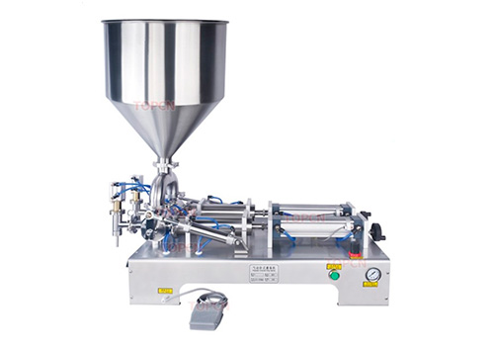

This machine is suitable for filling paste or liquid, such as honey, cream, gel, juice, mineral water, etc. It can be widely used in pharmaceutical, cosmetic, drink industries.

Attention

We also have two heads paste filling machine of this kind. Please contact us if you need.

Parameter

Model | G2WG paste filling machine
Voltage supply | 220/110V 50/60Hz
Power | 10W
Filling accuracy | ≤±1%
Filling speed | About 5-20 bottles/min
Filling volume | 10-100/10-200/30-300/50-500/100-1000
Filling volume | 250-2500ml/500-5000ml
Filling volume | (choose based on your requirement)
Equipped with air pressure | 0.4-0.6 MPa
Size of air compressor connector | OD 8mm
Air consumption | ≥0.1m3

